

**ROBOTEL**

**INTERIM PROJECT REPORT**

**Submitted by**

|  |  |
| --- | --- |
| **PRASANNA KUMAR.R** | **13BIC012** |
| **MATHIVANAN.D** | **13BIC020** |
| **SANTHOSH.N** | **13BIC030** |
| **VIGNESH.V** | **13BIC035** |

***In partial fulfillment for the award of the degree***

***of***

**Bachelor of Engineering**

**in**

**Instrumentation and Control Engineering**

**Dr.Mahalingam College of Engineering and Technology**

**Pollachi – 642003**

**An Autonomous Institution**

**Affiliated to Anna University, Chennai - 600 025**

**NOVEMBER 2016**

BONAFIDE CERTIFICATE

who carried out the project workunder my supervision.

|  |  |
| --- | --- |
| PRASANNA KUMAR R | 13BIC012 |
| MATHIVANAN.D | 13BIC020 |
| SANTHOSH.N | 13BIC030 |
| VIGNESH.V | 13BIC035 |

**Dr.Mahalingam College of Engineering and Technology**

**Pollachi – 642003**

**An Autonomous Institution**

**Affiliated to Anna University, Chennai -600 025**

**EXTERNAL EXAMINER**

**INTERNAL EXAMINER**

**Dr. K. Vijayakumar,M.E.,Ph.D.,**

**HEAD OF THE DEPARTMENT**

Associate Professor

Instrumentation and control Engineering

Dr. Mahalingam College of Engineering and Technology, NPT-MCET Campus

Pollachi – 642003

**Mr. P. Kathirvel,M.E.,**

**SUPERVISOR**

Assistant Professor

Instrumentation and control Engineering

Dr. Mahalingam College of Engineering and Technology, NPT-MCET Campus

Pollachi – 642003

Submitted for the Autonomous End Semester Examination Project work

viva-voce held on ____________________

Certified that this project report of,

**“ROBOTEL”**

is the bonafide work of

**ABSTRACT**

The project is based on an objective to develop a modern technology Robot for replacing the servers working in the hotel. The main aim of this project is to provide a remedy for the people working in the hotel as servers is to be replaced with robots so the efficiency of the delivery will also be good with respect to time, misplacement etc. This technology will also create a tremendous change in the autonomous world. The robot is developed in such a way that the robot has features to handle the food and clear the food when required. It also has the Speech instructions option where it will help the customers and the operators in the user friendly manner. It gives us each and every instruction as it works. Also it has the arm to deliver the food as well as to clear the food.

Initially the robot has to be connected with the mobile phone which is with the controller or in the kitchen of the hotel. Every table will be provided with a mobile phone that has our robotel application. That robotel application will be carrying the details of the table and the orders that are placed by the users. Those particular details will be transmitted to the mobile which is available at the kitchen. Through this technique the order details of the particular table will be received to the kitchen.

After this the controller who is sitting in the kitchen has to turn on the robot that is in the kitchen. The path of the kitchen is predefined and this can be changed according to the hotel to which the robot has to work. After developing the path and receiving the order details the controller has to place the food that is to be delivered on the robot. Once when the controller presses the table number to which the food is to be delivered the robot will start moving to the corresponding table. Respected table will be identified by the robot through encoding. From this encoding operation the tracking the path of the robot can be made possible.

Once when the robot reaches the respected table, through the robot speech operation it welcomes the customers and delivers the food and starts moving back to the kitchen.

**ACKNOWLEDGEMENT**

We extend our gratitude to our management for having provided us with all facilities to build our project successfully. We express our sincere thanks to our honorable Secretary**Prof. C. Ramaswamy, M.E., F.I.V.,** for providing us with required amenities.

We feel happy to express our sincere thanks to our Director (Academic) **Dr. S. Vijayarangan, M.E., Ph.D.,** for his support and encouragement.

We express our thanks to our Principal **Dr.M.Ramakrishnan,M.E.,Ph.D.,** who provided suitable environment to work with.

We express our gratefulness to **Dr.K.Vijayakumar,M.E.,Ph.D.,**Head of the Department, Instrumentation and Control Engineering for providing us kind advice during the development of the project.

Our hearty thanks to our guide **Mr.P.Kathirvel**.**,M.E.,** Assistant Professor, Instrumentation and Control Engineering, MCET, for his constant support and guidance offered to us during the course of our project by being one among us.

We are committed to place our heartfelt thanks to all teaching and non-teaching staff members, lab technicians and all the noble hearts that gave us immense encouragement towards the completion of our project. Finally we thank almighty for bestowing the gifts of life on us and also for providing us the necessary help through his lovely creations in this Endeavour of us.

**LIST OF ABBREVIATIONS**

US : Ultrasonic sensor

IR SENSOR : Infrared sensor

BT MODULE : Bluetooth module

DC : Direct current

BT : Battery

MC : Microcontroller

MD : Motor Driver

CC : Car Chassis

Specs : Specifications

BT App : Blue Terms Application

SS : Sound Sensor

SM : Servo Motor

RA : Robot Arm

**TABLE OF CONTENTS**

1. **INTRODUCTION** 1

1.1 Introduction about Robotics 1

2.**EXISTING MODEL** 2

2.1 Introduction 2

2.2 Proposed Model 3

**3. INFRARED SENSOR** 4

3.1 Introduction 4

3.2 Photoelectrictype IR sensor 4

3.3 Sensing mode 5

**4. POWER SUPPLY** 7

4.1 Battery 7

4.2 Battery charger 7

4.2.1 Types of battery charger 8

4.2.1.1 Simple chargers 8

4.2.1.2 Fast chargers 9

4.2.1.3 Inductive chargers 9

4.2.1.4 Intelligent chargers 9

4.2.1.5 Motion powered chargers 10

4.2.1.6 Pulse chargers 10

4.2.1.7 Solar chargers 10

4.2.1.8 Time based(HI) chargers 11

4.2.1.9 Trickle chargers 11

4.2.1.10 Universal battery chargers 12

4.2.1.11 USB based chargers 12

4.2.1.12 Power bank 12

**5. ULTRASONIC SENSOR** 14

5.1 Introduction 14

5.2 Working of ultrasonic sensor 15

5.3 Specifications 15

**6. BLUETOOTH MODULE** 16

6.1 Introduction 16

6.2 Features 16

6.3 Description 17

6.4 Working 19

**7. MOTOR DRIVER** 20

7.1 Introduction 20

7.2 Description 20

7.3 Working of motor driver 20

7.4 Specifications 21

**8. ARDUINO MEGA** 22

8.1 Introduction 22

8.2 General use of arduino 22

8.3 General features of arduino MEGA 22

8.4 Power(USB/power jack) 23

8.5 Pins 23

8.6 Reset button 24

8.7 Power LED indicator 24

8.8 Tx and Rx LED indicator 24

8.9 Main IC 24

8.10 Voltage regulator 24

**9. DC GEAR MOTOR** 25

9.1 Introduction 25

9.2 Specifications 25

9.3 Working 26

9.3.1 Back EMF 26

9.3.2 Significance of back EMF 27

**10. SD CARD MODULE** 28

10.1 Features 28

10.2 Overview 29

10.3 Use of Arduino 29

10.4 About different SD Cards 30

**11. GROVE SOUND SENSOR** 31

11.1 Sound Sensor 31

11.2 Grove Loudness sensor 32

11.3 Specifications 32

11.4 Engineering Connections 33

**12. SERVO MOTOR** 34

12.1 Mechanism 34

12.2 Specifications 37

**13. LCD**  38

13.1 Specifications 38

13.2 16*2 LCD module 40

13.3 LCD Initialization 41

13.4 Sending Data to LCD 42

**14. HARDWARE IMPLEMENTATION** 43

**15. SOFTWARE IMPLEMENTATION** 45

15.1 Algorithm 45

**16. FLOW CHART** 46

**17. ADVANTAGES** 52

**18. DISADVANTAGES** 52

**19. CONCLUSION** 52

**20. FUTURE SCOPE** 52

**LIST OF FIGURES**

Figure 1 Conveyor type System 2

Figure 2 Block Diagram of Robotel 3

Figure 3 InfraRed Sensor 5

Figure 4 InfraRed Sensor 6

Figure 5 Battery 13

Figure 6 Ultrasonic Sensor 15

Figure 7 Bluetooth Module 16

Figure 8 Motor Driver 21

Figure 9 Arduino MEGA 23

Figure 10 DC Geared Motor 25

Figure 11 SD Card Module 28

Figure 12 Arduino with SD Card Module 28

Figure 13 Grove Sound Sensor 31

Figure 14 Sound Sensor 31

Figure 15 Sound Sensor 32

Figure 16 Servo Motor 34

Figure 17 Schematic of Servo Motor 35

Figure 18 Servo Motor 37

Figure 19 LCD 38

Figure 20 Project Outlook 44

Figure 21 General Flow Chart 46

Figure 22 Flow Chart for Table 1 47

Figure 23 Flow Chart for Table 2 48

Figure 24 Flow Chart for Table 3 49

Figure 25 Flow Chart for Table 4 50

Figure 26 Flow Chart for Clearing the Tables 51

**LIST OF TABLES**

Table 1 Features and Implementation of Bluetooth Module 18

Table 2 Specifications of LCD 38

Table 3 16*2 LCD Module 40

1. INTRODUCTION

Firstly the word robot comes from the Czech word ‘*robotnik*‘which means forced labour or even slave. Watching movies like I Robot, Wall-E and reading various sci-fi novels of the past you’ll quickly see that robots have mostly always been portrayed as helpers and servants of humanity.

The[robots](https://en.wikipedia.org/wiki/Robot)has its origins on the [ancient world](https://en.wikipedia.org/wiki/Ancient_world). The modern concept began to be developed with the onset of the [IndustrialRevolution](https://en.wikipedia.org/wiki/Industrial_Revolution) which allowed for the use of complex mechanics and the subsequent introduction of electricity. This made it possible to power machines with small compact motors. In the early 20th century, the notion of a [humanoid](https://en.wikipedia.org/wiki/Humanoid) machine was developed. Today, it is now possible to envisage human sized robots with the capacity for near human thoughts and movement.

In the robot themed restaurant, the robots circle the room carrying trays of food in a conveyor beltlike system.The meals delivery robots move around the restaurant following a black stripe with optical tracking sensors. They are programmed to select the nearest way to delivery the  food  to  the assigned table.

The digital revolution has swept through industries across the globe as companies begin to grasp the potential benefits of automation and connectivity, both in terms of streamlining operations and reducing costs. Internet-related communication is fast becoming the consumer's favoured way of accessing goods and services, and the sight of factories without robotic production lines is becoming rarer with each passing year.

Generally, robots operate in the restaurant as entertainers, servers, greeters and receptionists. “Human can be temperamental or impatient, but they don’t feel tires, they just keep working and moving round and round the restaurant all night.” A restaurant owner told.

Similarly, many other methods are being followed in hotel management system for serving the food to the customers. It was then found that many drawback has been encountered in those form of hotel management systems. By considering the functions and the drawbacks of the above mentioned methodologies we have come up with our innovative ideas put together to implement a new kind of technology robot to serve food to the customers which will make a new revolution in hotel management systems.

**2. EXISTING MODEL**

**2.1 INTRODUCTION**

The foremost aim of the project is to make an easy the food delivery in the hotels and to increase the human values as well. So that these servers can be replaced with the robotel robots so that the delivery of the food in the hotels can be made easy with the help of the robots and the human values can be increased.

Normal hotels will be having the technique of the delivering the food by the servers, they will have to carry the food as well as they have to attend each of the tables to take the orders and also some of the peoples are there to clean the table. To treat the human and to increase the value of the humans they should be replaced with the robotel robots.

Other set of hotels will be carrying the conveyor type delivery system where they can place order through the computer attached with the HMI(Human Machine Interface). In these type of hotels the food will be continuously carried by the conveyor and when it reaches the table where you sit, you yourself have to take out the food, you yourself have to stop the conveyor at your point.

These problems can be rectified in the form of automating the same existing process by delivering the food by itself and clearing the customers by itself can increase.

**DISADVANTAGES OF EXISTING MODEL**



Figure 1: Conveyor type system

* Human values goes down
* More space occupation
* Energy loss
* Wrong delivery
* Labour
* Costly

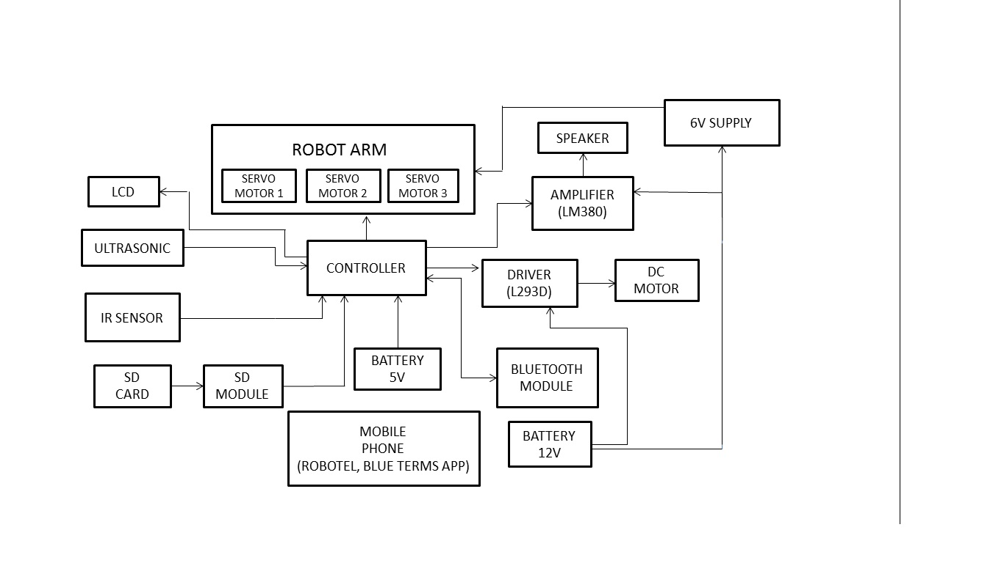**2.2 PROPOSED MODEL**

Figure 2: Block Diagram

**BLOCK DIAGRAM OF ROBOTEL**

3. INFRARED SENSOR

3.1 INTRODUCTION

A photoelectric sensor, or photo eye, is a device used to detect the distance, absence or presence of an object by using a light transmitter, often infrared and a photoelectric receiver. They are used extensively in industrial manufacturing. There are three different functional types: opposed (through beam), retro-reflective, and proximity-sensing (diffused).

3.2 PHOTOELECTRIC TYPE IR SENSOR

A self-contained photoelectric sensor contains the optics, along with the electronics. It requires only a power source. The sensor performs its own modulation, demodulation, amplification, and output switching. Some self-contained sensors provide such options as built-in control timers or counters. Because of technological progress, self-contained photoelectric sensors have become increasingly smaller. Remote photoelectric sensors used for remote sensing contain only the optical components of a sensor. The circuitry for power input, amplification, and output switching are located elsewhere, typically in a control panel. This allows the sensor, itself, to be very small. Also, the controls for the sensor are more accessible, since they may be bigger.

When space is restricted or the environment too hostile even for remote sensors, fiber optics may be used. Fiber optics is passive mechanical sensing components. They may be used with either remote or self-contained sensors. They may be used with either remote or self-contained sensors. They have no electrical activity and no moving parts, and can safely pipe light into and out of hostile environments.An individual PIR sensor detects changes in the amount of infrared radiation impinging upon it, which varies depending on the temperature and surface characteristics of the objects in front of the sensor.When an object, such as a human, passes in front of the background, such as a wall, the temperature at that point in the sensor's field of view will rise from room temperature to body temperature, and then back again. The sensor converts the resulting change in the incoming infrared radiation into a change in the output voltage, and this triggers the detection.Objects of similar temperature but different surface characteristics may also have a different infrared emission pattern, and thus moving them with respect to the background may trigger the detector as well.

**3.3 SENSING MODE**

An opposed (through beam) arrangement consists of a receiver located within the line-of-sight of transmitter. In this mode, an object is detected when the light beam is blocked from getting to the receiver from the transmitter.

A retro reflective arrangement places the transmitter and receiver at the same location and uses a reflector to bounce the light beam back from the transmitter to the receiver. An object is sensed when the beam is interrupted and fails to reach the receiver. A proximity-sensing (diffused) arrangement is one in which the transmitted radiation must reflect off the object in order to reach the receiver.

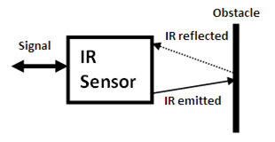

Figure 3:IR Sensor

In this mode, an object is detached when the receiver sees the transmitted source rather than when it fails to see it. Some photo eyes have two different operational types, light operate and dark operate. Light operate photo eyes become operational when the receiver “does not receive” the transmitter signal. The detecting range of a photoelectric sensor is its “field of view”, or the maximum distance the sensor can retrieve information from, minus the minimum distance. A minimum detectable object of minuscule size.PIRs come in many configurations for a wide variety of applications. The most common models have numerous Fresnel lenses or mirror segments, an effectiverange of about ten meters (thirty feet), and a field of view less than 180 degrees. Models with wider fields of view, including 360 degrees, are available—typically designed to mount on a ceiling.

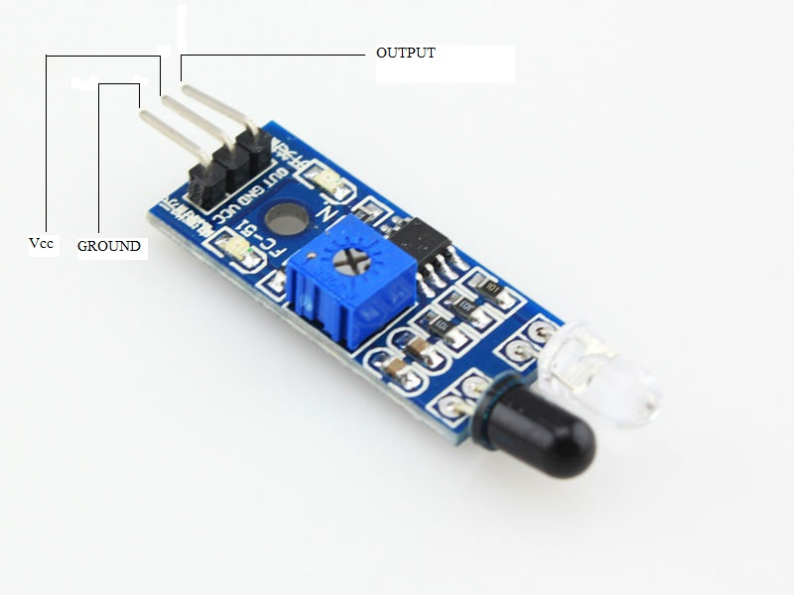

Figure 4: Infrared sensor

**FEATURES OF PHOTOELECRIC SENSORS**

LONG SENSING DISTANCE

A through-beam sensor, for example, candetectobjects more than 10 m away. This is impossible with magnetic, ultrasonic, or other sensing methods.

VIRTUALLY NO SENSING OBJECT RESTRICTIONS

These sensors operate on the principle that an object interrupts or reflects light, so they are not limited like proximity sensors to detect metal objects.This means they can be used to detect virtually any object, including glass, plastic, wood and liquid.

FAST RESPONSE TIME

The response time is extremely fast because light travels at high speed and the sensor performs no mechanical operations because all circuits are comprised of electronic components.

HIGH RESOLUTION

The incredibly high resolution achieved with these sensors derives from advanced design technologies that yielded a very small spot beam and a unique optical system forreceiving light. These developments enable detecting very small objects, as well as precise position detection.

EASY ADJUSTMENT

Positioning the beam on an object is simple with models that emit visible light because the beam is invisible.

NON CONTACTING SENSING

There is little chance of damaging sensing objects or sensors because objects can be detected without physical contact. This ensure years of sensor services.

**4. POWER SUPPLY**

**4.1 BATTERY**

An electric battery is a device consisting of one or more electrochemical cells with external connections provided to power electrical devices. A battery has a positive terminal, or cathode, and a negative terminal, or anode. The terminal marked positive is at a higher electrical potential energy than is the terminal marked negative. The terminal marked negative is the source of electrons that when connected to an external circuit will flow and deliver energy to an external device. When a battery is connected to an external circuit, electrolytes are able to move as ions within, allowing the chemical reactions to be completed at the separate terminals and so deliver energy to the external circuit. It is the movement of those ions within the battery which allows current to flow out of the battery to perform work. Historically the term "battery" specifically referred to a device composed of multiple cells, however the usage has evolved to additionally include devices composed of a single cell.

Primary (single-use or "disposable") batteries are used once and discarded; the electrode materials are irreversibly changed during discharge. Common examples are the alkaline battery used for flashlights and a multitude of portable devices. Secondary(rechargeable batteries) can be discharged and recharged multiple times; the original composition of the electrodes can be restored by reverse current. Examples include the lead-acid batteries used in vehicles and lithium-ion batteries used for portable electronics.

**4.2 BATTERY CHARGERS**

A battery charger or recharger is a device used to put energy into a secondary cell or an electric current through it.

The charging protocol depends on the size and type of the battery being charged. Some battery types have high tolerance for overcharging and can be recharged by connection to a constant voltage source or a constant current source; simple chargers of this type require manual disconnection at the end of the charge cycle, or may have a timer to cut off charging current at a fixed time. Other battery types cannot withstand long high-rate over-charging; the charger may have temperature or voltage sensing circuits and a microprocessor controller to adjust the charging current, determine the state of charge, and cut off at the end of charge.

A trickle charger provides a relatively small amount of current, only enough to counteract self-discharge of a battery that is idle for a long time. Slow battery chargers may take several hours to complete a charge; high-rate chargers may restore most capacity within minutes or less than an hour, but generally require monitoring of the battery to protect it from overcharge. Electric vehicles need high-rate chargers for public access; installation of such chargers and the distribution support for them is an issue in the proposed adoption of electric cars.

Charge and discharge rates are often denoted as C or C-rate, which is a measure of the rate at which a battery is charged or discharged relative to the capacity of the battery. The C-rate is given by the numerical value of the ratio of the charging or discharging current in A to the capacity of the battery in Ah.

For example, for a battery with a capacity of 500mAh, the current corresponding to a C-rate of 10 and a charge or discharge time of 6 minutes would be 5000mA or 5A, while the current corresponding to a C-rate of 1/2 and a charge or discharge time of 2 hours would be 250mA.

Very rapid charging rates, 1 hour or less, generally require the charger to carefully monitor battery parameters such as terminal voltage and temperature to prevent overcharging and damage to the cells.

**4.2.1 TYPES OF BATTERY CHARGERS**

**4.2.1.1 Simple chargers**

A simple charger works by supplying a constant DC or pulsed DC power source to a battery being charged. The simple charger does not alter its output based on time or the charge on the battery. This simplicity means that a simple charger is inexpensive, but there is a tradeoff in quality. Typically, a simple charger takes longer to charge a battery to prevent severe over-charging. Even so, a battery left in a simple charger for too long will be weakened or destroyed due to over-charging. These chargers can supply either a constant voltage or a constant current to the battery.

Simple AC-powered battery chargers have much higher ripple current and ripple voltage than other kinds of battery supplies. When the ripple current is within the battery-manufacturer-recommended level, the ripple voltage will also be well within the recommended level.

The maximum ripple current for a typical 12 V 100 Ah VRLA battery is 5 amps. As long as the ripple current is not excessive (more than 3 to 4 times the battery-manufacturer-recommended level), the expected life of a ripple-charged VRLA battery is within 3% of the life of a constant DC-charged battery.

**4.2.1.2 Fast chargers**

Fast chargers make use of control circuitry in the batteries being charged to rapidly charge the batteries without damaging the cells' elements. Most such chargers have a cooling fan to help keep the temperature of the cells under control. Most are also capable of acting as standard overnight chargers if used with standard NiMH cells that do not have the special control circuitry.

**4.2.1.3 Inductive chargers**

Inductive battery chargers use electromagnetic induction to charge batteries. A charging station sends electromagnetic energy through inductive coupling to an electrical device, which stores the energy in the batteries. This is achieved without the need for metal contacts between the charger and the battery. It is commonly used in electric tooth brushes

and other devices used in bathrooms. Because there are no open electrical contacts, there is no risk of electrocution.

**4.2.1.4 Intelligent chargers**

A "smart charger" should not be confused with a "smart battery". A smart battery is generally defined as one containing some sort of electronic device or "chip" that can communicate with a smart charger about battery characteristics and condition. A smart battery generally requires a smart charger it can communicate with (see Smart Battery Data). A smart charger is defined as a charger that can respond to the condition of a battery, and modify its charging actions accordingly.

Some smart chargers are designed to charge:

* "smart" batteries.
* "dumb" batteries, which lack any internal electronic circuitry.

The output current of a smart charger depends upon the battery's state. An intelligent charger may monitor the battery's voltage, temperature or time under charge to determine the optimum charge current and to terminate charging. The problem is, the magnitude of "delta-V" can become very small or even non-existent if (very) high[quantify] capacity rechargeable batteries are recharged.[citation needed] This can cause even an intelligent battery charger to not sense that the batteries are actually already fully charged, and continue charging. Overcharging of the batteries will result in some cases. However, many so called intelligent chargers employ a combination of cut off systems, which should prevent overcharging in the vast majority of cases.

A typical intelligent charger fast-charges a battery up to about 85% of its maximum capacity in less than an hour, then switches to trickle charging, which takes several hours to top off the battery to its full capacity.

**4.2.1.5 Motion-powered charger**

Linear induction flashlight, charged by shaking along its long axis, causing magnet (visible at right) to slide through a coil of wire (center) to generate electricity

Several companies have begun making devices that charge batteries based on regular human motion. One example, made by Tremont Electric, consists of a magnet held between two springs that can charge a battery as the device is moved up and down, such as when walking. Such products have not yet achieved significant commercial success.

**4.2.1.6 Pulse chargers**

Some chargers use pulse technology in which a series of voltage or current pulses is fed to the battery. The DC pulses have a strictly controlled rise time, pulse width, pulse repetition rate (frequency) and amplitude. This technology is said to work with any size, voltage, capacity or chemistry of batteries, including automotive and valve-regulated batteries. With pulse charging, high instantaneous voltages can be applied without overheating the battery. In a Lead–acid battery, this breaks down lead-sulfate crystals, thus greatly extending the battery service life.Several kinds of pulse charging are patented. Others are open source hardware.Some chargers use pulses to check the current battery state when the charger is first connected, then use constant current charging during fast charging, then use pulse charging as a kind of trickle charging to maintain the charge.

Some chargers use "negative pulse charging", also called "reflex charging" or "burp charging". Such chargers use both positive and brief negative current pulses. There is no significant evidence, however, that negative pulse charging is more effective than ordinary pulse charging.

**4.2.1.7 Solar chargers**

Solar chargers convert light energy into DC current. They are generally portable, but can also be fixed mount. Fixed mount solar chargers are also known as solar panels. Solar panels are often connected to the electrical grid, whereas portable solar chargers are used off-the-grid (i.e. cars, boats, or RVs).

**4.2.1.8 Timer-based(HI) chargers**

This section does not cite any sources. Please help improve this section by adding citations to reliable sources. Unisource material may be challenged and removed. The output of a timer charger is terminated after a pre-determined time. Timer chargers were the most common type for high-capacity Ni-Cd cells in the late 1990s for example (low-capacity consumer Ni-Cd cells were typically charged with a simple charger). Often a timer charger and set of batteries could be bought as a bundle and the charger time was set to suit those batteries. If batteries of lower capacity were charged then they would be overcharged, and if batteries of higher capacity were charged they would be only partly charged. With the trend for battery technology to increase capacity year on year, an old timer charger would only partly charge the newer batteries.

Timer based chargers also had the drawback that charging batteries that were not fully discharged, even if those batteries were of the correct capacity for the particular timed charger, would result in over-charging.

**4.2.1.9 Trickle chargers**

A trickle charger is typically a low-current (5–1,500 mA) battery charger. A trickle charger is generally used to charge small capacity batteries (2–30 Ah). These types of battery chargers are also used to maintain larger capacity batteries (> 30 Ah) that are typically found on cars, boats, RVs and other related vehicles. In larger applications, the current of the battery charger is sufficient only to provide a maintenance or trickle current (trickle is commonly the last charging stage of most battery chargers).

Depending on the technology of the trickle charger, it can be left connected to the battery indefinitely. Some battery chargers that can be left connected to the battery without causing the battery damage are also referred to as smart or intelligent chargers.These trickle chargers are typically found on cars, boats, RVs and other related vehicles. These chargers are not effected by any environmental condition and it can provide power to the batteries constantly. With this kind of chargers the batteries can be always kept powered and it also provides a good efficiency.

**4.2.1.10 Universal battery charger**

The most sophisticated types are used in critical applications (e.g. military or aviation batteries). These heavy-duty automatic “intelligent charging” systems can be programmed with complex charging cycles specified by the battery maker. The best are universal (i.e. can charge all battery types), and include automatic capacity testing and analyzing functions too.

**4.2.1.11 USB-based chargers**

Since the Universal Serial Bus specification provides for a five-volt power supply, it is possible to use a USB cable to connect a device to a power supply. Products based on this approach include chargers for cellular phones, portable digital audio players, and tablet computers. They may be fully compliant USB peripheral devices adhering to USB power discipline, or uncontrolled in the manner of USB decorations.

Although portable solar chargers obtain energy from the sun only, they still can (depending on the technology) be used in low light (i.e. cloudy) applications. Portable solar chargers are typically used for trickle charging, although some solar chargers (depending on the voltage), can completely recharge batteries. Other devices may exist, which combine this with other sources of energy for added recharging efficacy.

**4.2.1.12 Power bank**

A typical USB powerbank with the cover is used. The internal 18650 sizelithium-ion battery is exposed.Powerbanks are mostly popular for charging smartphones and mobile tablet devices. A powerbank is a portable device that can supply USB power using stored energy in its built-in batteries. Powerbanks usually recharge with USB power supply. Basically, powerbanks comprises the rechargeable batteries, consisting of either Lithium-ion or Lithium-Polymer cells and comes under protective casing, guided by sophisticated PCB ensuring various protective and safety measures. Portable power bank are comprised of a special battery in a special case with special circuit to control power flow. They allow us to store electrical energy and then later use it to charge up a mobile device.

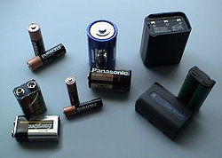

Figure 5: Batteries (dc power)

**SPECIFICATIONS**

* Capacity in mAh:[13] mAh stands for milli Ampere-hour and measures the amount of power flow that can be supplied by a certain powerbank. Amount of mA × time at 5V ideally. Many manufacturers measure this at the voltage of battery inside, hence they show more than actual.
* Simultaneous charging and discharging: need to specify if the powerbank can be used while it is charging.
* Number of output USB ports: This specifies the number of devices that can be charged simultaneously.
* Output current rating: This specifies the current rating that it can charge maximum. The higher the number.
* Input Current Rating: Input current rating is the amount of current the powerbank is able to draw at its maximum level while getting charged.
* Safety Protections: Over Voltage Protection, Over Charge Protections, Over Current Protections, Over Heat Protections, Short-Circuit Protections and Over Discharge Protections are the common safety measures observed with standard powerbanks.
* LED Indications: The Led glows as per indicating the amount of charging ability left with the power bank.

5. ULTRASONIC SENSOR

5.1 INTRODUCTION

Ultrasonic transducers are transducers that convert ultrasound waves to electrical signals or vice versa. Those that both transmit and receive may also be called ultrasound transceivers; many ultrasound sensors besides being sensors are indeed transceivers because they can both sense and transmit. These devices work on a principle similar to that of transducers used in radar and sonar systems, which evaluate attributes of a target by interpreting the echoes from radio or sound waves, respectively.   
Ultrasonic sensing techniques have become mature and are widely used in the various fields of engineering and basic science. Actually, many types of conventional ultrasonic instruments, devices and sophisticated software are commercialized and used for both industrial and medical applications. One of advantages of ultrasonic sensing is its outstanding capability to probe inside objectives nondestructively because ultrasound can propagate through any kinds of media including solids, liquids and gases except vacua. In typical ultrasonic sensing the ultrasonic waves are travelling in a medium and often focused on evaluating objects so that a useful information on the interaction of ultrasonic energy with the objects are acquired as ultrasonic signals that are the wave forms variations with transit time.

Such ultrasonic data provides the fundamental basis for describing the outputs of ultrasonic sensing and evaluating systems. In this chapter the fundamentals of ultrasonic sensing techniques are described. What is ultrasound, how to produce and capture ultrasound, what kinds of methods and equipments can be used to measure ultrasound, and what kinds of information can be obtained from ultrasonic measurements? These questions are addressed in the following sections and the answers to the questions are briefly explained from the viewpoint of industrial applications. In addition, some specialized results using a buffer rod sensor that is an effective means for high temperature ultrasonic measurements are introduced to demonstrate its applicability for nondestrucive evaluations and monitoring.

**5.2 WORKING OF ULTRASONIC SENSOR**

Active ultrasonic sensors generate high-frequency sound waves and evaluate the echo which is received back by the sensor, measuring the time interval between sending the signal and receiving the echo to determine the distance to an object. Passive ultrasonic sensors are basically microphones that detect ultrasonic noise that is present under certain conditions, convert it to an electrical signal, and report it to a computer.Ultrasonic probes and ultrasonic baths are used apply sound energy to agitate particles in a wide range of laboratory applications.

**5.3 SPECIFICATIONS**

* Detecting Range : 3cm to 4.5m.
* Detection Angle : 30 degree
* Power supply : 5v dc supply
* Ultrasonic frequency : 40 kHz
* Trigger pulse width : 10 µs
* Global current consumption : 15 mA

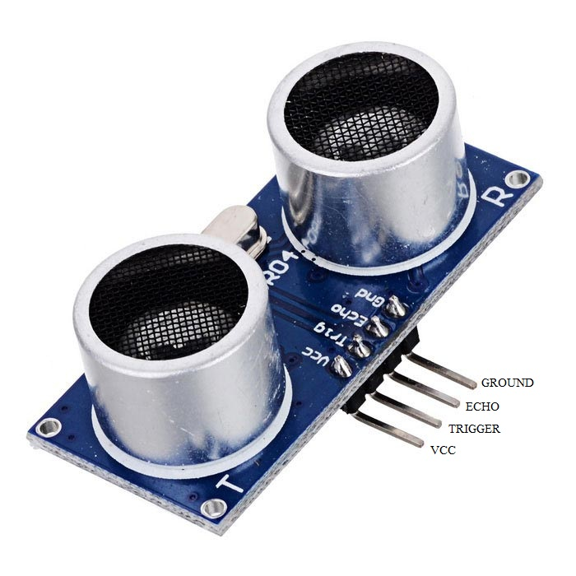

Figure 6: Ultrasonic sensor

6. BLUETOOTH MODULE

**6.1 INTRODUCTION**

The HC-05 Bluetooth Module [Product link] can be used in a Master or Slave configuration, making it a great solution for wireless communication. You can use it simply for a serial port replacement to establish connection between MCU and GPS, PC to your embedded project, etc.

Bluetooth is a technology for wireless communication, it is designed to replace cable connections. Usually, it connects small devices like mobile phones,PDAs and TVs using a short-range wireless connection. And it uses the 2.45 GHz frequency band. The connection can be point to point or multipoint .where the maximum range is 30meters. The transfer rate of the data is 1Mbps or maximum of 2Mbps.ssssss

HC-05Module is an easy to use Bluetooth spp(Serial port protocol) module, designed for transparent wireless serial connection setup. It is an serial port Bluetooth, drop in replacement for wired serial connections. Use it simply for a serial port replacement to establish connection between MCU and GPS,PC.

**6.2 FEATURES**

[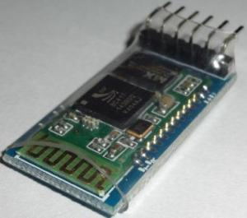](http://i0.wp.com/wiki.jmoon.co/wp-content/uploads/2014/11/JMBLHC05-1.jpg)

Figure 7: HC-05 Bluetooth module

* Protocol : Bluetooth Specification v2.0+EDR
* Frequency : 2.4GHz ISM band
* Modulation : GFSK
* Emission power : ≤4dBm, Class 2
* Sensitivity : ≤-84dBm at 0.1% BER
* Speed : Asynchronous: 2.1Mbps(Max) / 160 kbps
* Security : Authentication and encryption
* Profiles : Bluetooth serial port
* Power supply : +3.3VDC 50mA
* Working temperature : -20 ~ +75 Centigrade

**6.3 DESCRIPTION**

The HC-05 Bluetooth Module has 6 pins- Vcc, GND, TX, RX, Key, and LED. It comes pre-programmed as a slave, so there is no need to connect the Key pin, unless you need it change it to Master Mode.

The major difference between Master and Slave modes is that, in Slave mode the Bluetooth module cannot initiate a connection, it can however accept incoming connections. After the connection is established the Bluetooth module can transmit and receive data regardless of the mode it is running in. If you are using a phone to connect to the Bluetooth module, you can simply use it in the Slave mode. The default data transmission rate is 9600kbps.

It has 6 leads in this module. But genuinely care about only four of them. Where, the two are for vcc and GND.VCC=power supply(in other words 5V or 3.3V). GND=Ground or 0Volt. And the next two leads are for RX(Receiving end) and TX(ransmitting end).

RX of the module will go to the TX of the Arduino UNO. In the same way ,we connect the TX of the module with the RX of the Arduino UNO. In addition , can add a LED to determine the output more correctly. So add a LED to digital pin12.

The range for Bluetooth communication is usually 30m or less. The module has a factory set pin of “1234” which is used while pairing the module to a phone.

**PIN CONNECTIONS**:

HC-05 GND Vcc TX RX Key LEDArduinoGND3.3V/5V RX/SoftRx TX/SoftTx _______

**FEATURES AND IMPLIMENTATION**

Table 1: Features and Implementation of Bluetooth Module

|  |  |  |
| --- | --- | --- |
| **S.NO** | **Features** | **Implementation** |
| 1 | Power supply | +3.3VDC 5Ma |
| 2 | Power saving | <4dBm, class 2 |
| 3 | Frequency bands | 2.4GHz ISM band |
| 4 | Modulation | GFSK(Gaussian Frequency Shift Keying |
| 5 | Sensitivity | <-8.4dBm at 0.1%BER |
| 6 | Speed | Asynchronous:2.1Mbps/160kbps  Synchronous:1Mbps/1Mbps |
| 7 | Temperature range | -20 to +75 centigrade |
| 8 | Dimensions | 26.9mm*13mm*2.2mm |
| 9 | Security | Authentication and encryption |
| 10 | Profile | Bluetooth serial port |

**6.4 WORKING**

To understand how a Bluetooth connection works, we need an example of the wireless technology being used, so let’s take a phone connected to wireless speaker. First, each device is equipped with Bluetooth connectivity, a feature that requires both software and hardware components. On the hardware side, an antenna-equipped chip in both devices sends and receives signals at a specific frequency. The software interprets incoming Bluetooth signals and sends them out in ways other devices can read and understand. In the case of the wireless speaker, the phone will know how to send audio files and information in a format that the speaker understands, while the speaker can interpret these signals–as well as other indicators such as volume and track controls–from the phone.

When two devices are equipped with Bluetooth, usually one of them will to be set to be discoverable, meaning it’ll show up in a list of Bluetooth devices in the area on your phone or other controlling device. Using our example, the wireless speaker would be discoverable, and it will end up being controlled by a Bluetooth-equipped phone or remote. The speaker, or any Bluetooth accessory, sends out a signal with a little bit of information to alert other nearby devices of its presence and capabilities. You tell your phone to connect, and the two devices form a personal area network, or piconet.

From this point on, the two devices know to connect with each other based on the unique address within their respective signals. No matter what other signals come in on wavelengths in which those devices operate operate, they will always detect, read, and send the correct signals. Bluetooth signals have a limited range, which prevents massive amounts of conflicting data covering huge areas and interrupting communication between other devices.

**7. MOTOR DRIVER**

**7.1 INTRODUCTION**

L293D is a Motor driver integrated circuit which is used to drive DC motors rotating in either direction. It is a 16-pin IC which can control a set of two DC motors simultaneously. The L293D uses 5V for its own power and external power source is nee. The L293D works on the concept of typical H-bridge, a circuit which allows the high voltage to be flown in either direction. In a single L293D IC there two H-bridge circuits which can rotate two DC motors independently. Due to its size and voltage requirement, it is frequently used in robotics applications for controlling DC motors, including in Arduino projects. The L293D is also a key component in larger 'motor driver' boards available premade for hobbyists. To drive the motors, which can be up to 36V and draw up to 600mA.

**7.2 DESCRIPTION**

There are two Enable pins on L293D. Pin 1 (left H-bridge) and pin 9 (right H-bridge). To drive the corresponding motor, pin 1 or 9 need to be set to HIGH. If either pin 1 or pin 9 goes low then the motor in the corresponding section will suspend working.The four Input pins for the L293D are pin 2 and 7 on the left and pin 15 and 10 on the right as shown on the pin diagram. Left input pins will regulate the rotation of motor connected on the left side and right input for motor on the right hand side. The motors are rotated on the basis of the inputs provided at the input pins as LOGIC 1 or LOGIC 0.

**7.3 WORKING**

A DC motor is any of a class of electrical machines that converts direct current electrical power into mechanical power. The most common types rely on the forces produced by magnetic fields. Nearly all types of DC motors have some internal mechanism, either electromechanical or electronic, to periodically change the direction of current flow in part of the motor. Most types produce rotary motion; a linear motor directly produces force and motion in a straight line.

DC motors were the first type widely used, since they could be powered from existing direct-current lighting power distribution systems. A DC motor's speed can be controlled over a wide range, using either a variable supply voltage or by changing the strength of current in its field windings. Small DC motors are used in tools, toys, and appliances. The universal motor can operate on direct current but is a lightweight motor used for portable power tools and appliances. Larger DC motors are used in propulsion of electric vehicles, elevator and hoists, or in drives for steel rolling mills.

**7.4 SPECIFICATIONS**

* Voltage range : 4.5v to 36v
* Current : 100 mA to drive motor
* Max resistance : 60 Ώs
* o/p current capability : 600 mA
* Pulsed current : 1.2 mA per drive.
* Package : 16 pin DIP
* Ic weight : 2 gram

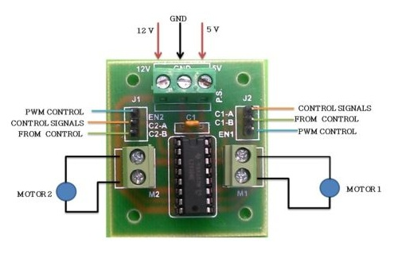

Figure 8: Motor driver

8. ARDUINO mega

8.1 INTRODUCTION OF ARDUINO

[Arduino](http://arduino.cc/) is an open-source platform used for building electronics projects. Arduino consists of both a physical programmable circuit board (often referred to as a [microcontroller](http://en.wikipedia.org/wiki/Microcontroller)) and a piece of [software](http://arduino.cc/en/Main/Software), or IDE (Integrated Development Environment) that runs on your computer, used to write and upload computer code to the physical board.The Arduino platform has become quite popular with people just starting out with electronics, and for good reason. Unlike most previous programmable circuit boards, the Arduino does not need a separate piece of hardware (called a programmer) in order to load new code onto the board – you can simply use a USB cable. Additionally, the Arduino IDE uses a simplified version of C++, making it easier to learn to program. Finally, Arduino provides a standard form factor that breaks out the functions of the micro-controller into a more accessible package.

8.2 GENERAL USE OF ARDUINO

The Arduino hardware and software was designed for artists, designers, hobbyists, hackers, newbies, and anyone interested in creating interactive objects or environments. Arduino can interact with buttons, LEDs, motors, speakers, GPS units, cameras, the internet, and even your smart-phone or our TV. This flexibility combined with the fact that the Arduino software is free, the hardware boards are pretty cheap, and both the software and hardware are easy to learn has led to a large community of users who have contributed code and released instructions for a **huge** variety of Arduino-based projects.For everything from [robots](https://learn.sparkfun.com/tutorials/building-the-hub-ee-buggy) and a [heating pad hand warming blanket](https://learn.sparkfun.com/tutorials/heating-pad-hand-warmer-blanket) to [honest fortune-telling machines](https://learn.sparkfun.com/tutorials/the-uncertain-7-cube),  [Dragons dice-throwing gauntlet](http://www.sparkfun.com/tutorials/333), the Arduino can be used as the brains behind almost any electronics project.

**8.3 GENERAL FEATURES OF ARDUINO MEGA**

Arduino Uno is one of the types belongs to the Arduino family. It has 54 digital input/output pins (of which 6 can be used as PWM outputs), 16 analog inputs, a USB connection, a power jack, a reset button and more. It contains everything needed to support the microcontroller; simply connect itto a computer with a USB cable or power it with a AC-to-DC adapter or battery to get started.

Figure 9: Arduino MEGA

8.4 POWER (USB/ BARREL JACK)

Every Arduino board needs a way to be connected to a power source. The Arduino MEGA can be powered from a USB cable coming from the computer or a wall power supply that is terminated in a barrel jack. Do not use a power supply greater than 20 Volts because the Arduino will get damaged. The recommended voltage for most Arduino models is between 6 and 12 Volts.

### 8.5PINS (5V, 3.3V, GND, ANALOG, DIGITAL, PWM, AREF)

The pins on Arduino are the places where the wires can be connected to construct a circuit probably in conjunction with a [breadboard](https://learn.sparkfun.com/tutorials/how-to-use-a-breadboard/) and some [wire](https://learn.sparkfun.com/tutorials/working-with-wire). They usually have black plastic ‘headers’ that allows to just plug a wire right into the board. The Arduino has several different kinds of pins, each of which is labeled on the board and used for different functions.

* **GND:** Short for ‘Ground’. There are several GND pins on the Arduino, any of which can be used to ground the circuit.
* **5V & 3.3V:** The 5V pin supplies 5 volts of power and the 3.3V pin supplies 3.3 volts of power. Most of the simple components used with the Arduino run happily off of 5 or 3.3 volts.
* **Analog:** The area of pins under the ‘Analog In’ label (A0 through A5 on the MEGA) is Analog In pins. These pins can read the signal from an analog sensor (like a [temperature sensor](https://www.sparkfun.com/products/10988)) and convert it into a digital value that we can read.
* **Digital:** Across from the analog pins are the digital pins (0 through 13 on the MEGA). These pins can be used for both digital input (like telling if a button is pushed) and digital output (like powering an LED).
* **PWM:** The tilde (~) next to some of the digital pins (3, 5, 6, 9, 10, and 11 on the MEGA) act as normal digital pins, but can also be used for something called Pulse-Width Modulation (PWM).

8.6 RESET BUTTON

Arduino has a reset button. Pushing it will temporarily connect the reset pin to ground and restart any code that is loaded on the Arduino.

8.7 POWER LED INDICATOR

The LED in the Arduino board should light up whenever Arduino is plugged into a power source. If this light doesn’t turn on, then it means that there is some problem with the power supply and the board.

8.8 TX AND RX LED INDICATORS

TX is short for transmit, RX is short for receive. These markings appear quite a bit in electronics to indicate the pins responsible for [serial communication](https://learn.sparkfun.com/tutorials/serial-communication). There are two places on the Arduino MEGA where TX and RX appear – once by digital pins 0 and 1, and a second time next to the TX and RX indicator LEDs. These LEDs will give us some nice visual indications whenever our Arduino is receiving or transmitting data.

8.9 MAIN IC

The black thing with all the metal legs is an IC, or Integrated Circuit. Think of it as the brains of our Arduino. The main IC on the Arduino is slightly different from board type to board type, but is usually from the ATmega line of IC’s from the ATMEL Company.

8.10 VOLTAGE REGULATOR

The voltage regulatoris not actually something you can (or should) interact with on the Arduino. The voltage regulator controls the amount of voltage that is let into the Arduino board. Think of it as a kind of gatekeeper; it will turn away an extra voltage that might harm the circuit.

**9. DC MOTOR**

**9.1 INTRODUCTION**

Synchronous motors are like induction motor in that they both have stator windings to produce a rotating magnetic field.It has speed of 60RPM AC Synchronous Motors ranging from 3 kg-cm Torque at 60 RPM at 50HZ to 80 kg-cm Torque at 60 RPM at 50HZ.With high grade aluminiumcasing,SSshaft,high grade stamping,high grade copper winding and high quality ball bearings.Normally the synchronous motors ranges were size from sub-fractional horsepower to 10,000 horsepower (HP).Similarly small synchronous motor is mainly used for the household device like timer,fansetc.Large synchronous motors are used in process industries and drive equipment.

**9.2 SPECIFICATION**

* 12v DC Motor with gear box
* Motor speed = 60rpm
* Base motor speed = 3000rpm
* Shaft diameter = 6mm(with internal hole)
* Weight = 125gm
* Torque = 2kgcm
* No-load current = 60mA(max)
* Load current = 300mA(max)

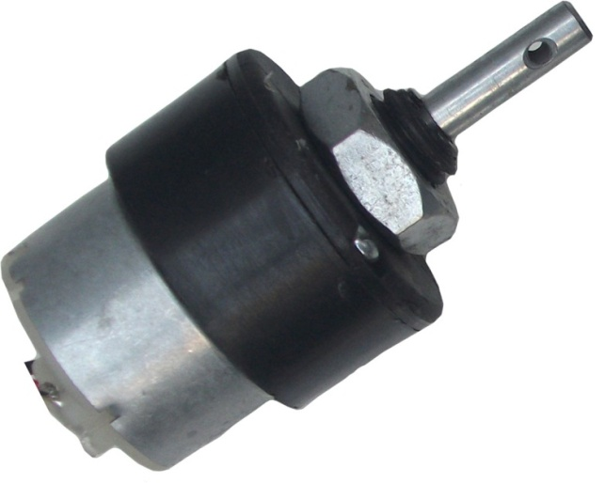

Figure 10: DC GEAR MOTOR

**9.3 WORKING**

A motor is an electrical machine which converts electrical energy into mechanical energy. The principle of working of a DC motor is that "whenever a current carrying conductor is placed in a magnetic field, it experiences a mechanical force". The direction of this force is given by Fleming's left hand rule and it's magnitude is given by F = BIL. Where, B = magnetic flux density, I = current and L = length of the conductor within the magnetic field.

Fleming's left hand rule: If we stretch the first finger, second finger and thumb of our left hand to be perpendicular to each other AND direction of magnetic field is represented by the first finger, direction of the current is represented by second finger then the thumb represents the direction of the force experienced by the current carrying conductor.

When armature windingsare connected to a DC supply, current sets up in the winding. Magnetic field may be provided by field winding (electromagnetism) or by using permanent magnets. In this case, current carrying armature conductors experience force due to the magnetic field, according to the principle stated above.

Commutator is made segmented to achieve unidirectional torque. Otherwise, the direction of force would have reversed every time when the direction of movement of conductor is reversed the magnetic field.

While a dc generator converts mechanical energy in the form of rotation of the conductor(armature) into electrical energy, a motor does the opposite. The input to dc motor is electrical and the output is mechanical rotation or torque.

DC series motor motors, the field winding is connected in series with armature.the field winding should have less number of turns of wire. The resistance of the series field winding should be very small.

**9.3.1 Back EMF**

According to fundamental laws of nature, no energy conversion is possible until there is something to oppose the conversion. In case of generators this opposition is provided by magnetic drag, but in case of dc motors there is back emf.When the armature of the motor is rotating, the conductors are also cutting the magnetic flux lines and hence according to the Faraday's law of electromagnetic induction, an emf induces in the armature conductors. The direction of this induced emf is such that it opposes the armature current (Ia). The circuit diagram below illustrates the direction of the back emf and armature current. Magnitude of Back emf can be given by the emf equation of DC generator.

**9.3.2 Significance of Back EMF**

Magnitude of back emf is directly proportional to speed of the motor. Consider the load on a dc motor is suddenly reduced. In this case, required torque will be small as compared to the current torque. Speed of the motor will start increasing due to the excess torque. Hence, being proportional to the speed, magnitude of the back emf will also increase. With increasing back emf armature current will start decreasing. Torque being proportional to the armature current, it will also decrease until it becomes sufficient for the load. Thus, speed of the motor will regulate.

On the other hand, if a dc motor is suddenly loaded, the load will cause decrease in the speed. Due to decrease in speed, back emf will also decrease allowing more armature current. Hence, being proportional to the speed, magnitude of the back emf will also increase.The direction of this induced emf is such that it opposes the armature current.Increased armature current will increase the torque to satisfy the load requirement. Hence, presence of the back emf makes a dc motor ‘self-regulating’.

**10. SD CARD MODULE**

The Arduino SD card Shield is a simple solution for transferring data to and from a standard SD card. The pinout is directly compatible with Arduino, but can also be used with other microcontrollers. It allows you to add mass storage and data logging to your project.

[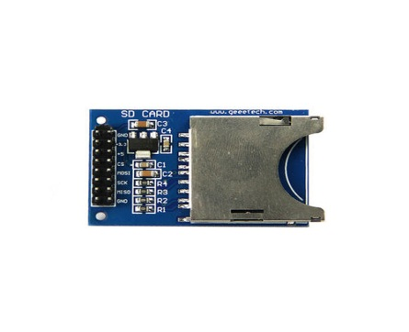](http://www.geeetech.com/wiki/index.php/File:IMG_0283.jpg)

Figure 11: SD Card Module

**10.1 FEATURES**

* Break out board for standard SD card.
* Contains a switch to select the flash card slot
* Sits directly on a Arduino
* Also be used with other microcontrollers

[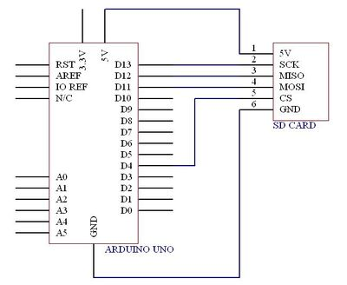](http://www.geeetech.com/wiki/index.php/File:SD_card_wiring.jpg)

Figure 12: Arduino with SD Card Module

### 10.2 OVERVIEW

**SD cards work only at 3.3V and both the power and I/O levels must be accommodated. The module shown here uses FETs for level shifting and a 3.3V regulator for power when operating from 5.0V. A switch allows the module to be used with Arduinos/ YourduinoRobo 1 or Minis etc. running at 3.3V. We have tested the YourDuinoRobo 1 with it’s power jumper set to 3.3V and the SD card module set at 3.3V and it works well.**

This module also has a MicroSD socket on the back side, and we have tested 2GB and 4GB MicroSD cards plugged in there. They worked OK with the SdFAT library. These cards are formatted FAT32 and SD/HC.  
*SPI:  
10 (SS) "Slave Select"  
11 (MOSI) "Master Out Slave In"  
12 (MISO) "Master In Slave Out"  
13 (SCK) "System Clock"  
  
To clarify this: to connect this module you must connect:  
(Arduino Pin) - Module Pin  
**10 (SS) to CS  
11 (MOSI) to DI  
12 (MISO) to DO  
13 (SCK) to CLK**  
and **G to GND** and **+ to 5V**  
AND.. Switch the switch to 5V for any Arduino running on 5V.

## **10.3 USE WITH ARDUINO/YOURDUINO MEGA VERSIONS**

The Arduino hardware page for ArduinoMegas shows this pinout, so needed connections are:  
**SPI:  
50 (MISO) to DO  
51 (MOSI) to DI  
52 (SCK) to CLK  
53 (SS) to CS**and **G to GND** and **+ to 5V**  
AND.. Switch the switch to 5V for any Arduino running on 5V.

These Mega pins support SPI communication using the [SPI library](http://arduino.cc/en/Reference/SPI). The SPI pins are also broken out on the ICSP header, which is physically compatible with the Uno, Duemilanove and Diecimila.

## 

## **10.4 ABOUT DIFFERENT SD CARDS**

Some SD cards work fine, some do not. You may have to try a few. Most cards have good SPI read performance but cards vary widely in SPI write performance. Write performance is limited by how efficiently the card manages internal erase/remapping operations. The Arduino cannot optimize writes to reduce erase operations because of its limited RAM. SanDisk cards generally have good write performance. They seem to have more internal RAM buffering than other cards and therefore can limit the number of flash erase operations that the Arduino forces due to its limited RAM. Some Dane-Elec cards have a write speed that is only 20% as fast as a good SanDisk card.

**11. GROVE SOUND SENSOR**

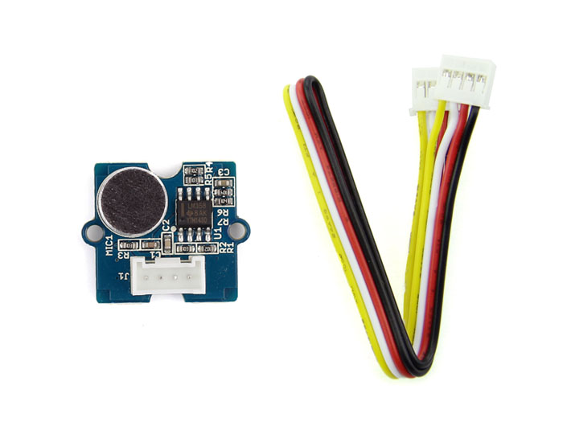

Figure 13: Sound sensor

Grove - Sound Sensor can detect the sound strength of the environment. The main component of the module is a simple microphone, which is based on the LM358 amplifier and an electret microphone. This module’s output is analog and can be easily sampled and tested by a Seeeduino.

**11.1 SOUND SENSOR**

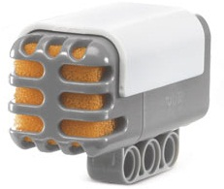

Figure 14: Sound sensor

There are several types of sound sensors (microphones) like dynamic microphone, condenser microphone, ribbon microphone, carbon microphone etc. Our microphone is dynamic and uses induction coil positioned in the magnetic field of a permanent magnet attached to the diaphragm. When you make a sound, the diaphragm vibrates and thus the attached coil moves in the magnetic field, producing current. The sound sensor is able to measure noise levels in decibels (dB) at frequencies around 3-6kHz where the human ear is most sensitive. There are android applications for your smart phone for measuring sound level, like decibel meter.

**11.2 GROVE LOUDNESS SENSOR**

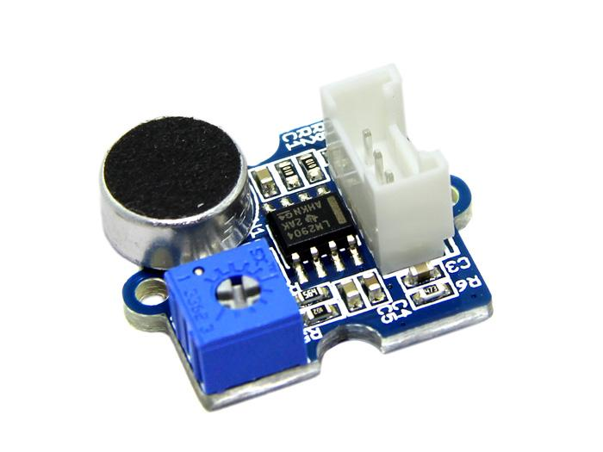

Figure 15:SoundSensor

The Grove - Loudness Sensor is designed to detect the loudness of environmental sound. Based on amplifier LM2904 and a built-in microphone, it amplifies and filters the high frequency signal that received from the microphone, and outputs a positive envelop. This will make for Arduino’s signal acquisition. The output value depends on the level of sound input. In order to avoid unnecessary signal disturbances, input signal will go through two times’ filtering inside the module. Lastly, there is a screw potentiometer that enables manual adjustments to the output gain.

## **11.3 SPECIFICATIONS**

* Voltage ： 3.5~10 VDC
* Working Frequency ： 50~2000 Hz
* Sensitivity  : -48~66 dB
* Signal-to-noise Ratio  : >58 dB
* Output Signal range  : Analog Signal (0-1023)

Students learn about how sound sensors work, reinforcing their similarities to the human sense of hearing. They look at the hearing processsound waves converted to electrical signals sent to the brainthrough human ear anatomy as well as sound sensors. A mini-activity, which uses LEGO MINDSTORMS NXT intelligent bricks and sound sensors gives students a chance to experiment with the sound sensors in preparation for the associated activity involving the sound sensors and taskbots. A PowerPoint presentation explains stimulus-to-response pathways, sensor fundamentals, the unit of decibels, and details about the LEGO sound sensor, including how readings are displayed and its three modes of programming sound input. Students take pre/post quizzes and watch a short online video. This lesson and its associated activity enable students to appreciate how robots can take sensor input and use it to make decisions to via programming.

### 11.4 ENGINEERING CONNECTION

Sound sensorscalled auditory sensors by engineersare used in many devices that we use every day. The stimulus-to-response pathways seen in electronic sound sensor operation mimics the human body process that involves our ears and signal transmission to the brain. Microphones are the sound sensors used in phones, computers, baby monitors and music systems like karoke machines. The use of sensors has exploded into the design of uncountable every day tools, equipment, appliances and devices.

**12. SERVO MOTOR**

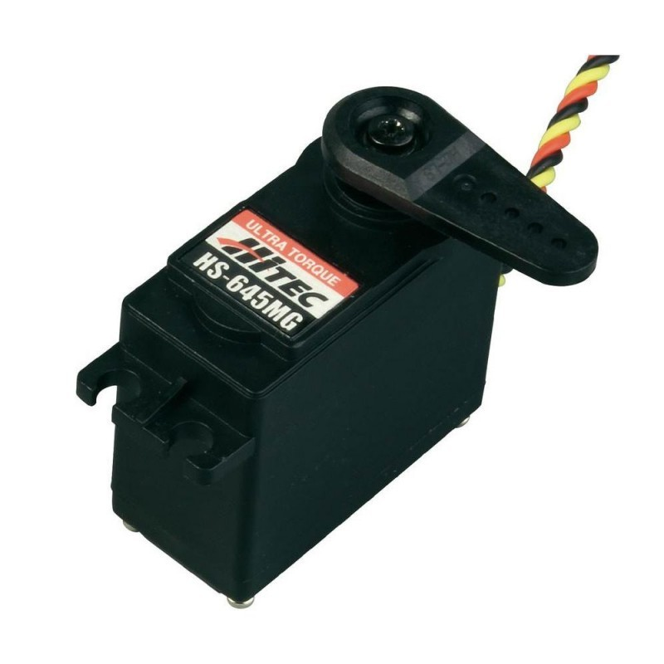

Figure 16: Servo Motor

A servomoto**r** is a [rotary actuator](https://en.wikipedia.org/wiki/Rotary_actuator) or [linear actuator](https://en.wikipedia.org/wiki/Linear_actuator) that allows for precise control of angular or linear position, velocity and acceleration.It consists of a suitable motor coupled to a sensor for position feedback. It also requires a relatively sophisticated controller, often a dedicated module designed specifically for use with servomotors.

Servomotors are not a specific class of motor although the term *servomotor* is often used to refer to a motor suitable for use in a closed-loop control system.

Servomotors are used in applications such as [robotics](https://en.wikipedia.org/wiki/Robotics), [CNC](https://en.wikipedia.org/wiki/CNC) machinery or automated manufacturing.

**12.1 MECHANISM**

A servomotor is a [closed-loop](https://en.wikipedia.org/wiki/Closed-loop_controller) [servomechanism](https://en.wikipedia.org/wiki/Servomechanism) that uses position feedback to control its motion and final position. The input to its control is some signal, either analogue or digital, representing the position commanded for the output shaft.

The motor is paired with some type of [encoder](https://en.wikipedia.org/wiki/Encoder) to provide position and speed feedback. In the simplest case, only the position is measured. The measured position of the output is compared to the command position, the external input to the controller. If the output position differs from that required, an [error signal](https://en.wikipedia.org/wiki/Error_signal) is generated which then causes the motor to rotate in either direction, as needed to bring the output shaft to the appropriate position. As the positions approach, the error signal reduces to zero and the motor stops.

The very simplest servomotors use position-only sensing via a [potentiometer](https://en.wikipedia.org/wiki/Potentiometer) and [bang-bang control](https://en.wikipedia.org/wiki/Bang-bang_control) of their motor; the motor always rotates at full speed (or is stopped). This type of servomotor is not widely used in industrial [motion control](https://en.wikipedia.org/wiki/Motion_control), but it forms the basis of the simple and cheap[servos](https://en.wikipedia.org/wiki/Servo_(radio_control)) used for [radio-controlled models](https://en.wikipedia.org/wiki/Radio-controlled_model).

More sophisticated servomotors use optical [rotary encoders](https://en.wikipedia.org/wiki/Rotary_encoder) to measure the speed of the output shaft and a variable-speed drive to control the motor speed. Both of these enhancements, usually in combination with a [PID control](https://en.wikipedia.org/wiki/PID_controller) algorithm, allow the servomotor to be brought to its commanded position more quickly and more precisely, with less [overshooting](https://en.wikipedia.org/wiki/Overshoot_(signal))

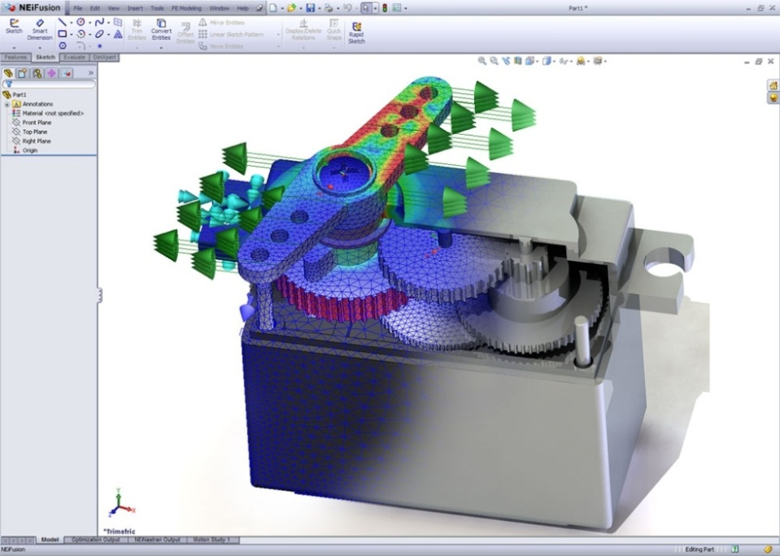

Figure 17: Servo Motor

A servomotor consumes power as it rotates to the commanded position but then the servomotor rests. [Stepper motors](https://en.wikipedia.org/wiki/Stepper_motor) run warm to the touch because they continue to consume power to lock in and hold the commanded position.

Servomotors are generally used as a high-performance alternative to the stepper motor. Stepper motors have some inherent ability to control position, as they have built-in output steps. This often allows them to be used as an open-loop position control, without any feedback encoder, as their drive signal specifies the number of steps of movement to rotate, but for this the controller needs to 'know' the position of the stepper motor on power up. Therefore, on first power up, the controller will have to activate the stepper motor and turn it to a known position, e.g. until it activates an end limit switch. This can be observed when switching on an [inkjet printer](https://en.wikipedia.org/wiki/Inkjet_printing); the controller will move the ink jet carrier to the extreme left and right to establish the end positions. A servomotor will immediately turn to whatever angle the controller instructs it to, regardless of the initial position at power up.

The lack of feedback of a stepper motor limits its performance, as the stepper motor can only drive a load that is well within its capacity, otherwise missed steps under load may lead to positioning errors and the system may have to be restarted or recalibrated. The encoder and controller of a servomotor are an additional cost, but they optimise the performance of the overall system (for all of speed, power and accuracy) relative to the capacity of the basic motor. With larger systems, where a powerful motor represents an increasing proportion of the system cost, servomotors have the advantage.

There has been increasing popularity in closed loop [stepper motors](https://en.wikipedia.org/wiki/Stepper_motor) in recent years. They act like servomotors but have some differences in their software control to get smooth motion. The top 3 manufacturers of closed loop stepper motor systems employ magnetic encoders as their feedback device of choice due to low cost, and resistance to vibration. The main benefit of a closed loop stepper motor is the cost to performance ratio. There is also no need to tune the [PID controller](https://en.wikipedia.org/wiki/PID_controller) on a closed loop stepper system saving time.

Many applications, such as [laser cutting](https://en.wikipedia.org/wiki/Laser_cutting) machines, may be offered in two ranges, the low-priced range using stepper motors and the high-performance range using servomotors.

The type of motor is not critical to a servomotor and different types may be used. At the simplest, brushed permanent magnet DC motors are used, owing to their simplicity and low cost. Small industrial servomotors are typically electronically commutated brushless motors. For large industrial servomotors, AC induction motors are typically used, often with [variable frequency drives](https://en.wikipedia.org/wiki/Variable_frequency_drive) to allow control of their speed. For ultimate performance in a compact package, brushless AC motors with permanent magnet fields are used, effectively large versions of [Brushless DC electric motors](https://en.wikipedia.org/wiki/Brushless_DC_electric_motor).

Drive modules for servomotors are a standard industrial component. Their design is a branch of [power electronics](https://en.wikipedia.org/wiki/Power_electronics), usually based on a three-phase MOSFET or IGBT [H bridge](https://en.wikipedia.org/wiki/H_bridge). These standard modules accept a single direction and pulse count (rotation distance) as input. They may also include over-temperature monitoring, over-torque and stall detection features. As the encoder type, gearhead ratio and overall system dynamics are application specific, it is more difficult to produce the overall controller as an off-the-shelf module and so these are often implemented as part of the main controller.

**12.2 SPECIFICATIONS**

* Weight = 55g
* Dimension = 40.7x19.7x42.9mm
* Stall torque = 11kgf.cm
* Operating speed = 0.14s/60˚
* Operating voltage = 6v
* Running current = 500mA-900mA
* Stall current = 2.5A
* Dead band width = 5µs

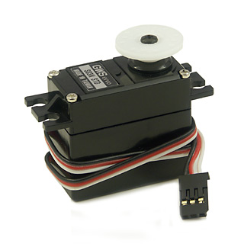

Figure 18: Servo Motor

**13. LCD(LIQUID CRYSTAL DISPLAY)**

16*2 LCD module is a very common type of LCD module that is used in 8051 based embedded projects. It consists of 16 rows and 2 columns of 5*7 or 5*8 LCD dot matrices. The module were are talking about here is type number jHD162A which is a very popular one. It is available in a 16 pin package with back light, contrast adjustment function and each dot matrix has 5*8 dot resolution. The pin number, their name and corresponding functions are shown below,

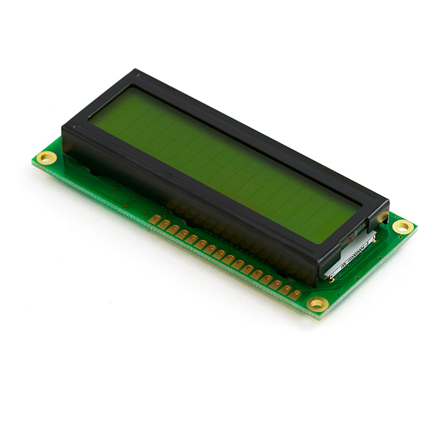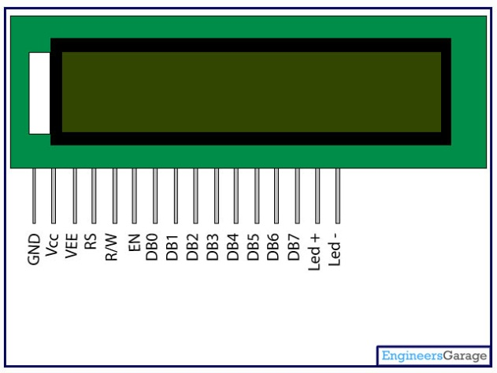

Figure 19: LCD

**13.1 SPECIFICATIONS**

* Supply voltage = 4.7-5.3v
* Backlight Vcc = 5v
* 8bit data pins = DB0-DB7
* Command register selection = low
* Data register selection = high
* Contrast adjustment through variable resistance
* Low to write to the register
* High to read from the register
* Sends data to data pins when a high to low pulse is given

Table 2: Specifications of LCD

|  |  |  |
| --- | --- | --- |
| **Pin No:** | **Name** | **Function** |
| **1** | **VSS** | This pin must be connected to the ground |
| **2** | **VCC** | Positive supply voltage pin (5V DC) |
| **3** | **VEE** | Contrast adjustment |
| **4** | **RS** | Register selection |
| **5** | **R/W** | Read or write |
| **6** | **E** | Enable |
| **7** | **DB0** | Data |
| **8** | **DB1** | Data |
| **9** | **DB2** | Data |
| **10** | **DB3** | Data |
| **11** | **DB4** | Data |
| **12** | **DB5** | Data |
| **13** | **DB6** | Data |
| **14** | **DB7** | Data |
| **15** | **LED+** | Back light LED+ |
| **16** | **LED-** | Back light LED- |

VEE pin is meant for adjusting the contrast of the LCD display and the contrast can be adjusted by varying the voltage at this pin. This is done by connecting one end of a POT to the Vcc (5V), other end to the Ground and connecting the center terminal (wiper) of of the POT to the VEE pin. See the circuit diagram for better understanding.

The JHD162A has two built in registers namely data register and command register.  Data register is for placing the data to be displayed , and the command register is to place the commands. The 16×2 LCD module has a set of commands each meant for doing a particular job with the display. We will discuss in detail about the commands later. High logic at the RS pin will select the data register and  Low logic at the RS pin will select the command register. If we make the RS pin high and the put a data in the 8 bit data line (DB0 to DB7) , the LCD module will recognize it as a data to be displayed .  If we make RS pin low and put a data on the data line, the module will recognize it as a command.

R/W pin is meant for selecting between read and write modes. High level at this pin enables read mode and low level at this pin enables write mode.

E pin is for enabling the module. A high to low transition at this pin will enable the module.

DB0 to DB7 are the data pins. The data to be displayed and the command  instructions are  placed on these pins.

LED+ is the anode of the back light LED and this pin must be connected to Vcc through a suitable series current limiting resistor. LED- is the cathode of the back light LED and this pin must be connected to ground.

**13.2 16×2 LCD MODULE COMMANDS**

16×2 LCD module has a set of preset command instructions. Each command will make the module to do a particular task. The commonly used commands and their function are given in  the  table below.

Table 3: 16*2 LCD Module commands

|  |  |
| --- | --- |
| Command | Function |
| 0F | LCD ON, Cursor ON, Cursor blinking ON |
| 01 | Clear screen |
| 02 | Return home |
| 04 | Decrement cursor |
| 06 | Increment cursor |
| 0E | Display ON ,Cursor blinking OFF |
| 80 | Force cursor to the beginning of  1st line |
| C0 | Force cursor to the beginning of 2nd line |
| 38 | Use 2 lines and 5×7 matrix |
| 83 | Cursor line 1 position 3 |
| 3C | Activate second line |
| 08 | Display OFF, Cursor OFF |
| C1 | Jump to second line, position1 |
| OC | Display ON, Cursor OFF |
| C1 | Jump to second line, position1 |
| C2 | Jump to second line, position2 |

**13.3 LCD INITIALIZATION**

The steps that has to be done for initializing the LCD display is given below and these steps are common for almost all applications.

* Send 38H to the 8 bit data line for initialization
* Send 0FH for making LCD ON, cursor ON and cursor blinking ON.
* Send 06H for incrementing cursor position.
* Send 01H for clearing the display and return the cursor.

**13.4 SENDING DATA TO THE LCD**

The steps for sending data to the LCD module is given below. I have already said that the LCD module has pins namely RS, R/W and E. It is the logic state of these pins that make the module to determine whether a given data input  is a command or data to be displayed.

* Make R/W low.
* Make RS=0 if data byte is a command and make RS=1 if the data byte is a data to be displayed.
* Place data byte on the data register.
* Pulse E from high to low.
* Repeat above steps for sending another data.

**14. HARDWARE IMPLEMENTATION**

Firstly the customer who is sitting in front of the table will be provided with a mobile phone. Each of the mobile phones will be installed with the robotel app. The application will ask for the details such as the table number in which they are sitting and after selecting the corresponding table number it shows the menu card. The list of the items displaying in the application can be changed whenever we want to change the items or the rate of the item. This application will be user friendly so that any of the users can handle it very simply.

Similarly another mobile with the installed robotel application will be provided to the controller or the kitchen person. This application acts as the receiver for the application which is going to transmit the information. This application communicates with the other application through the Bluetooth available with the mobile phone.

Through this way the orders can be placed or cancelled as much as the customers do. When the order is received from any one of the customers the controller should have to make ready the items which have been placed by the customers. When the controller places the food on the robot, through the robot speech instructions the robot will ask the controller to select the respected table to which the food has to be delivered.

When the controller presses the table number, the robot starts moving. The robot movement or the path of the robot is pre-defined through the line follower technique. This line can be made in any way as for as the design of the floor of the hotel at which the robot has to work. Through the line follower technique and with the help of the IR sensors the path of the robot is programmed and for the identification of the tables, the technique used in this robot is encoders. After reaching the respected table, the robot will welcome the customers through robot speech instructions. After that it delivers the food which is placed on the robot through the help of the robot arm. Here we have used three axis robot along with the gripper. Three servo motors have been used to deliver the food.

After delivering the food to the respected table the robot will automatically come back to the kitchen. While the robot is moving around the tables, when the robot faces any objects as the obstacle it will stop moving. This operation is made through the help of the ultrasonic sensor. While delivering the food simultaneously when the customers place the waste food on the robot, it wishes the customers and come back to the kitchen and troughs the plates at the kitchen.

When the controller comes to know that the customer is going to leave the hotel, he will again send the robot the respected table and the robot will itself clear the table.

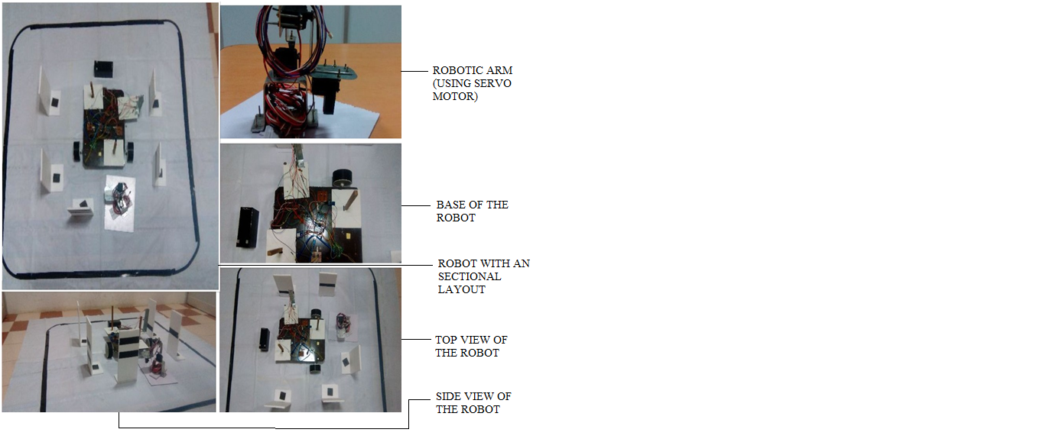:

Figure 20Project outlook

**15. SOFTWARE IMPLEMENTATION**

**15.1 ALGORITHM**

1) Turn on the robot from the input of clap sensor.

2) Connect the mobile with the robot.

3) Enter the password.

4) Select any one table to which the food is to be delivered.

5) The table numbers/numbers to be selected are

1) Table 1 - Delivery

2) Table 2 - Delivery

3) Table 3 - Delivery

4) Table 4 - Delivery

5) Kitchen

6) Table 1 - Clearing

7) Table 2 - Clearing

8) Table 3 - Clearing

9) Table 4 - Clearing

6) If any of the table number is selected the robot will travel towards the respected/selected table number and it delivers the food.

7) When any of the customers place the waste food simultaneously when the robot is delivering the food, it collects the waste food on the robot and travels towards the kitchen.

8) Whenever any of the food or waste food is placed on the robot it will be keep on tracking through the help of the IR sensor.

9)Whenever the food is placed on either side of the robot it will process take the control action accordingly.

**16. FLOWCHART**

Start

Connect with

Mobile phone

Turn on the

Robot

Sound sensor

Input

Turn on the

LED

Select any table for

Food Delivery

Figure 21: General Flow Chart

**TABLE-1**

**1**

Table-1

(001)

Robot speech

Instructions

Servo operation

Robot Arm

if W.F==1

**YES NO**

Kitchen

(101)

Kitchen

(101)

Robot arm

operation

Figure 22: Flow Chart for table 1

**TABLE-2**

**2**

Table-2

(010)

Robot speech

Instructions

Servo operation

Robot Arm

if W.F==1

**YES NO**

Kitchen

(101)

Kitchen

(101)

Robot arm

operation

Figure 23: Flow Chart for table 2

**TABLE-3**

**3**

Table-3

(011)

Robot speech

Instructions

Servo operation

Robot Arm

if W.F==1

**YES NO**

Kitchen

(101)

Kitchen

(101)

Robot arm

operation

Figure 24: Flow Chart for table 3

**TABLE-4**

**4**

Table-4

(100)

Robot speech

Instructions

Servo operation

Robot Arm

if W.F==1

**YES NO**

Kitchen

(101)

Kitchen

(101)

Robot arm

operation

Figure 25: Flow Chart for table 4

**CLEARING THE TABLE**

Select any table number for

Clearing the table

Robot goes to that

Particular table

Robot arm

operation

Kitchen

(101)

Robot arm

operation

Figure 26: Flow Chart for Clearing the tables

**17. ADVANTAGES**

* It may control any crowds with priority constrains.
* Low maintenance
* It gives its entire dedication and maximum work capacity even 24*7.
* Initial investment is enough.

**18. DISADVANTAGES**

* If there is any malfunction in the robot in any of the sensors the system fails in its operation.
* When the power of the system goes down, it may cause some malfunction in its operation.

**19. CONCLUSION**

The project is based on an objective to develop a modern technology Robot for replacing the servers working in the hotel. The main aim of this project is to provide a remedy for the people working in the hotel as servers is to be replaced with robots so the efficiency of the delivery will also be good with respect to time, misplacement etc. This technology will also create a tremendous change in the autonomous world. The robot is developed in such a way that the robot has features to handle the food and clear the food when required. It also has the Speech instructions option where it will help us in the hence of the customers and the operators in the user friendly manner. It gives us each and every instruction as it works. Also it has the arm to deliver the food as well as to clear the food. So this may be the best replacement for the existing model.

**20. FUTURE SCOPE**

A battery back up can be made in this system so as to with stand the power in terms of the malfunction. The robot arm can be enhanced by adding the number of axis in its arm so the functioning of the arm will be more effective and the jerks can be eliminated completely. Number of sensors can be increased for adding more number of tables.

REFERENCES

[1] Rajkamal, “**Embedded System Architecture, Programming and Design**”, Tata McGrawhillPublising Company Ltd, Second edition, 2008

[2] John.b.peatman, “**Design with Microcontrollers**”, Pearson Education, 2002.

[3] Tim Wihurst, “**An Introduction to the design of Small Scale Embedded System**”

, Palgrave, 2004

[4] Frank Vahid, Tony Givargis, “**Embedded System Design**”, Wiley India, 2006.

[5] Tammy Noergaard, “**Embedded Systems Architecture**”, Elsevier, 2005.

[6] Ajay V. Deshmukh, “**Microcontrollers Theory And Applications**”, Tata McGraw Hill Publising Company Ltd, 2008

[7] Cooper. W. D and Helfrick. A. D, "**Modern Instrumentation and Measurement Techniques**", Third Edition, Prentice-Hall of India, 2008.

[8] Patranabis. D, "**Principles of Electronic Instrumentation**", PHI Learning Pvt Ltd, 2008.

[9] Chesmond, Wilson and Lepla, "**Advanced Control System Technology**", Viva low priced student edition, 1998